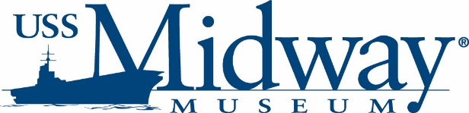

USS MIDWAY MUSEUM OFFERS FREE ADMISSION TO SAN DIEGO COUNTY TEACHERS

Teacher Appreciation offer from May 1-31

The USS Midway Museum is providing complimentary single-day admission for active and certified K-12 San Diego County credentialed classroom teachers as a teacher appreciation offer during the month of May 2024

Teachers continue to work incredibly hard to provide quality education to our county’s youth, and as a learning museum, Midway has tremendous appreciation for all their incredible efforts. This FREE ticket offer is Midway’s way of recognizing and saying thank you to our countywide teachers.

This complimentary ticket offer is available at the Midway ticket booth only. Teachers must provide proof by presenting a teacher credential ID. The offer is available to teachers only.

Additional information can be found at https://www.midway.org/visit/special-offers

USS Midway Museum marketing contact: David Koontz / dkoontz@midway.org

