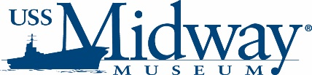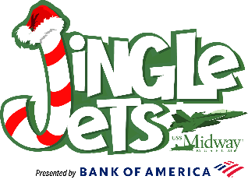
USS Midway Museum Taking Holiday Lighting Extravaganza to New Levels
Jingle Jets adding more nights, more lights and more fun
The USS Midway Museum will be decked out from bow to stern with 750,000 twinkling and shimmering lights to celebrate this year’s holidays with “Jingle Jets,” its second annual festive lighting experience. This jubilant evening event will take place on 21 selective days starting in mid-November and running through Christmas.
As San Diego’s newest and most unique holiday tradition in San Diego, Midway will again be transformed from a mighty warship into a winter wonderland with an aviation twist bringing an extraordinary holiday spirit to the San Diego Bayfront.
“We were delighted by the incredibly positive feedback we received from our guests last year about our inaugural Jingle Jets celebration,” said Mark Berlin, Midway’s director of operations and guest services. “It is truly a one-of-a-kind holiday experience and we’re excited to bring it back.”
Jingle Jets will encompass Midway’s flight deck and hangar deck, as well as a portion of its lower deck. Along with nearly all of Midway’s aircraft being wrapped in holiday lights, wintery holiday tree forests, brilliantly lit tunnels and life-size holiday ornaments shining throughout the ship, the museum is adding several significant enhancements, including 250,000 more lights, to the experience.
New for 2024, Midway’s virtual reality experience and full-motion simulators will thrill guests with exhilarating holiday-themed rides. Children can participate in the exclusive “Operation Penguin Pursuit” scavenger hunt to find all the life-size penguin holiday ornaments placed around the ship to win a special prize.
Every Friday and Saturday, Jingle Jets guests will be able to take part in the all-new “Christmas Carol Karaoke,” where they can sing along to all the holiday classics. The museum is also adding three special nights – “Bring Your Dog Night in Holiday Costume” on Nov. 26, “Christmas Pajama Night” on Dec. 3 and “Ugly Sweater Night” on Dec. 8.
The Jingle Jets experience will continue to include a Santa Claus meet & greet, carolers, holiday music DJ and dance floor, holiday treats and delicious eats, seasonal merchandise, the opportunity to write thank-you letters to military service members, and various photo and interaction opportunities.
“Jingle Jets will again bring the San Diego waterfront alive over the holidays,” said Cheryl Carlson, Midway’s director of special events. “With all the new additions we’re bringing to Jingle Jets this year, we know our guests will have an amazing holiday experience. There’s nothing like it in San Diego.”
Jingle Jets will begin on Friday, Nov. 22 and run on 21 selective nights through Dec. 23 from 5:30 – 9:30 p.m. Tickets will go on sale, online only, on Oct. 21. Additional information on Jingle Jets is available on the museum’s website.
Jingle Jets is proudly sponsored by Bank of America.
#
Media Contact:
David Koontz
Director of Marketing
dkoontz@midway.org
619.398.8207

